**Website Correction**

* Company name incorrect in snippet page should be change

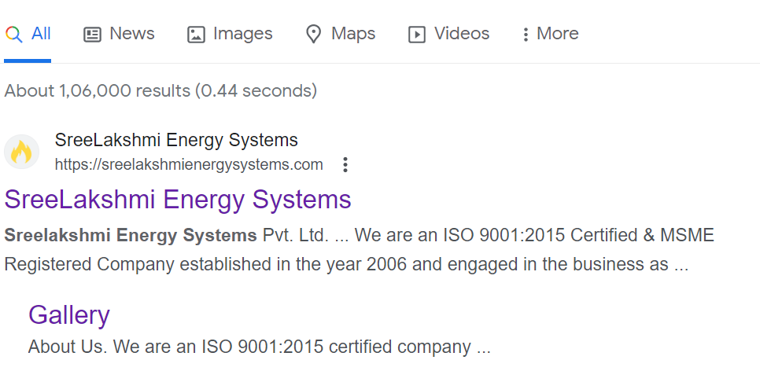

**About Page**

* Create new banner for header

**Solution Page**

1. **Piped Natural Gas Installation (PNG)**

* Graph size reduce bigger

**Products**

* Add products name

**Gallery**

* Add accounts photos
* Photos viewable option
* Remove photos gap

**Contact Us**

* Not working Message Us option